**CS4200 -- Project 1: 8-Puzzle**

**Due on: Jul. 19, 2020**

|  |  |
| --- | --- |
|  | Please use either Java or C++ |

**Project Description**

The A* search can be used to solve the 8-puzzle problem. As described in the book, there are two candidate heuristic functions: (1) h1 = the number of misplaced tiles; (2) h2 = the sum of the distances of the tiles from their goal positions.

You are to implement the A* using both heuristics and compare their efficiency in terms of depth of the solution and search costs.  The following figure provides some data points that you can refer to (you don’t need to report “effective branching factor” in your report). To test your program and analyze the efficiency, you should generate random problems (>100 cases) with different solution lengths or you can use the inputs that I provided to test your program. Please collect data on the different solution lengths that you have tested, with their corresponding search cost (# of nodes generate). A good testing program should test a range of possible cases (2 <= d <= 20). Note that the average solution cost for a randomly generated 8-puzzle instance is about 22 steps.

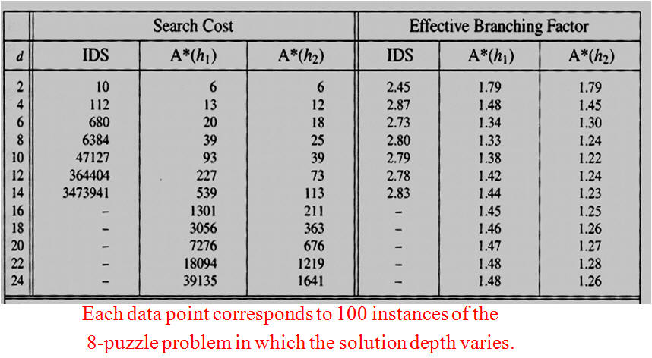

Figure Search Costs for H1 and H2

**Input requirements**: Your program should allow the instructor to either generate a random 8-puzzle problem or enter a specific 8-puzzle configuration through the standard input, which contains the configuration for only one puzzle, in the following format:

1 2 4  
0 5 6  
8 3 7

The goal state is:

0 1 2  
3 4 5  
6 7 8

Where 0 represents the empty tile.

Please handle the input/output gracefully.

Note that the 8-puzzle states are divided into two disjoint sets, such that any state is reachable from any other state in the same set, which no state is reachable from any state in the other set. Before you solve a puzzle, you need to make sure that it's solvable. Here's how.

Definition: For any other configuration besides the goal, whenever a tile with a greater number on it precedes a tile with a smaller number, the two tiles are said to be inverted.

Proposition: For a given puzzle configuration, let N denote the sum of the total number of inversions. Then (N mod 2) is invariant under any legal move. In other words, after a legal move an odd N remains odd whereas an even N remains even. Therefore the goal state described above, with no inversions, has N = 0, and can only be reached from starting states with even N, not from starting states with odd N.

**What to Submit?**

* Project report (your approach + comparison of the two approaches + other analysis + findings), including a **table** similar to the Figure above, *without the branching factor*, but with new columns about the average run time and the number of cases you've tested with a specific length. (<3 pages, word/pdf format.).
* Source code + README (how to compile or run your code).
* Program output: three sample solutions with solution depths (<6, between 6 to 12, > 12). Your program should output each step from the initial state to the final state. For your testing purposes, you'll still need to test it with 100 cases and document them in the table.
* Please create a folder called "yourname_4200p1" that includes all the required files and generate a zip file called "yourname_4200p1.zip".
* Please submit your work (.zip) through Blackboard. (In case you encounter any Blackboard problem during submission, you can send a separate email to the instructor with your submission attached. Please do so by the deadline.)

-5 per day penalty will be applied for late submissions.